# CS 340 README Template

## About the Project/Project Title

Grazioso Salvare Identification of Potential Rescue Animals

*Identifying dogs for search and rescue operations*

## Motivation

*The purpose of this project is to streamline the search efforts for identifying canine candidates for search and rescue training and operations. It hopes to use search criteria to identify dogs of specific breeds and ages that would be optimal for different search and rescue operations.*

## Getting Started

*To get started locally have the python file downloaded on your computer. Open jupyter notebooks and*

*import and instantiate the file as an object.*

*Import the AAC data into the database*



*If a user account is not set up the one will need to be to prevent administrative access*

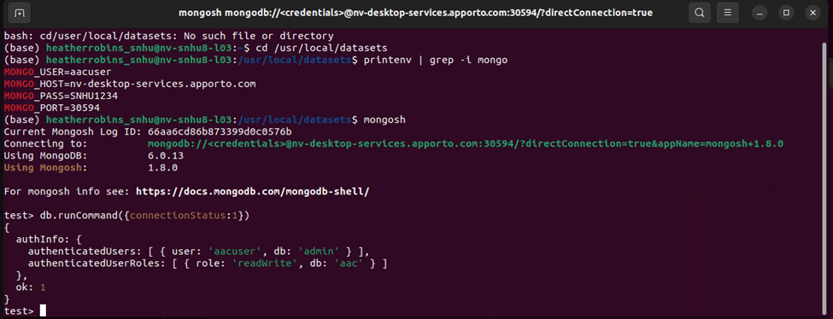

## Installation

*The only requirement currently is python, to install it locally go to:*

[*https://www.python.org/downloads/*](https://www.python.org/downloads/)

*and download the appropriate python file*

*The Python driver for MongoDB is also what we will be working with as well. As it is easy and simple to use with MongoDB.*

*Use:*

*python3 -m pip install pymongo*

*in the python terminal to get started.*

*Make sure to have the amimalshelter.py and the ProjectTwoDashboard.ipynb files download as well. Run the ProjectTwoDashboard.ipynb file to get started.*

## Usage

*With animalshelter.py and the ProjectTwoDashboard.ipynb files you can run the Dashboard and perform searches for preferred animals for different rescue operations. The filtering options are currently for Water rescue, mountain rescue, and disaster rescue. You can also search for a sort by each category in the list like breed or animal_type.*

*Apon getting the results you are also presented with a pie chart that shows the filtered breeds as well, it can be changed to show the top 5, 10, 15 or all the breeds filtered.*

*Apon selecting an animal in a row presented the map below will also update to show the location of that selected animal as well as show the breed when hovering over the marker.*

### Code Example

For the filtering of rescue types:

### Tests

*The last filtering option is in the list itself. You can type in what you want to search in each column as well as turn on and of case-sensitivity as well as sort by highest/lowest or alphabetical.*

### Screenshots

Scrolling down you will also see a pie chart representing the data presented above. As well as a map with a marker on the location of the currently selected animal in the above data.

Going back to the top there are four radio buttons to select : Water Rescue, Mountain Rescue, Disaster Rescue, and Reset. Selecting the different options will result in the preferred animals for that rescue type being filtered in.

*The last filtering option is in the list itself. You can type in what you want to search in each column as well as turn on and of case-sensitivity as well as sort by highest/lowest or alphabeticly.*

*Going back down to the Graph. It is automatically only showing the top 5 breeds, clicking on the drop down menu next to the text “Graph Total” you will get the options of 5, 10, 15, or all. This shows the number of breeds represented in the pie chart.*

*The last current feature of the pie chart is that you can hover over a section of the chart and it will give you the breed and number of that breed*

*The map also has a similar feature as you can hover over the marker to get the breed that is selected.*

## Roadmap/Features (Optional)

*Future feature will include a better layout, having the graph and map more evenly lined up and equal sizes. I also want to change the graph to have the labels and percentages inside the graph as well as in the legend beside it. I also want to better center the map to have a more optimal look at the markers when selecting animals.*

## Contact

Robin Robinson